**CHAPTER-1**

**INTRODUCTION**

Voice assistance technology has revolutionized the way humans interact with machines. From virtual assistants on smartphones to smart home devices, voice assistants use natural language processing (NLP) to understand and respond to spoken commands. This technology aims to enhance user experience by providing handsfree, efficient, and intuitive interactions.

Voice assistants are intelligent software applications that use natural language processing and speech recognition to understand and respond to spoken commands. They can perform a variety of tasks, from setting reminders and playing music to providing weather updates and controlling smart home devices. Popular examples include Amazon's Alexa, Apple's Siri, Google Assistant, and Microsoft's Cortana.

These assistants leverage artificial intelligence to improve their understanding over time, making interactions more intuitive and userfriendly. With the rise of smart devices, voice assistants are increasingly integrated into our daily lives, transforming how we interact with technology and access information.

Voice assistants not only enhance convenience but also promote accessibility for users with disabilities or those who may struggle with traditional interfaces. By enabling voice commands, these technologies allow individuals to perform tasks handsfree, which can significantly improve their quality of life. For example, voice controlled devices can assist visually impaired users in navigating their environment, while those with mobility challenges can manage home automation systems without physical interaction. As the technology continues to evolve, we can expect even greater capabilities that further bridge the gap between users and their devices.

Moreover, the integration of voice assistants into various sectors, such as healthcare, education, and customer service, demonstrates their versatility and potential for impact. In healthcare, for instance, voice assistants can help medical professionals manage patient data, schedule appointments, and even remind patients to take medications. In education, they can facilitate interactive learning experiences, allowing students to engage with content through voice queries. As industries recognize the benefits of this technology, we are likely to see more innovative applications that enhance productivity and enrich user experiences across diverse fields.

Additionally, as voice recognition technology improves, we can expect to see more personalized experiences tailored to individual user preferences. This could include recognizing different voices within a household and adjusting responses or settings accordingly. Privacy and security concerns are also being addressed, with advancements in encryption and user authentication ensuring that interactions remain secure. Furthermore, the ongoing development of multilingual capabilities will make voice assistants more inclusive, catering to diverse linguistic backgrounds. Ultimately, the future of voice assistance technology holds immense promise, paving the way for even more seamless and integrated human machine interactions.

Voice assistance systems have revolutionized the way people interact with technology, offering a hands-free, intuitive interface for performing tasks through spoken commands. By leveraging advancements in Natural Language Processing (NLP), speech recognition, and machine learning, these systems can understand and respond to user requests, ranging from simple actions like setting reminders to more complex functions like controlling smart home devices or retrieving information. As voice assistants become increasingly integrated into everyday devices—from smartphones to IoT ecosystems—they enhance convenience, accessibility, and efficiency, making technology more personal and adaptive to individual user needs.

**CHAPTER-2**

**PROJECT OVERVIEW**

**1. Objective of the Project**

The objective of the voice assistance project is to develop an intelligent, voice-activated platform that allows users to interact seamlessly with devices, applications, and services. This system aims to simplify and streamline everyday tasks such as retrieving information, controlling smart home devices, sending messages, and managing schedules, all through natural, spoken commands. By leveraging advanced technologies like Natural Language Processing (NLP) and machine learning, the voice assistant will provide accurate, context-aware responses while personalizing user interactions based on individual preferences, ultimately enhancing accessibility, convenience, and user experience across multiple platforms and devices.

The primary objective of a voice assistance system is to create an intelligent platform that allows users to interact with devices, applications, or services through voice commands. The goal is to simplify tasks such as controlling smart home devices, retrieving information, sending messages, or performing searches, while offering a seamless and userfriendly experience. Voice assistants leverage natural language processing (NLP) and machine learning to understand and respond to users’ needs accurately and efficiently.

In addition to simplifying everyday tasks, the objective of a voice assistance system extends to enhancing accessibility for users with disabilities, enabling them to interact with technology more easily through voice commands. It aims to provide personalized experiences by learning user preferences over time, adapting responses, and anticipating needs. The system should be versatile, capable of handling various tasks, from managing schedules to controlling a wide range of devices, all while maintaining high levels of accuracy and contextual understanding. Moreover, the integration of voice assistants across multiple platforms ensures that users can access its features seamlessly, whether they are at home, at work, or on the go, making the technology a convenient, hands-free solution for digital interaction.

**2. Ethical Considerations**

Ethical considerations in voice assistance systems focus on user privacy, data security, and transparency. Since voice assistants often listen continuously, ensuring user consent and protecting sensitive information is crucial. Developers must implement strong data encryption and restrict access to voice recordings. Bias in language processing, such as misinterpreting accents or dialects, should be minimized to ensure fairness and inclusivity. There are concerns about over-reliance on technology, so systems should empower user autonomy. Additionally, companies must be transparent about data usage, provide opt-out options, and maintain accountability for misuse or breaches in privacy.

**3. Technological Implications**

Technological implications of voice assistance systems involve advancements in Natural Language Processing (NLP) and Machine Learning (ML) to understand and adapt to user commands more effectively. Speech recognition technology is critical for accurately interpreting spoken words, requiring improvements in noise reduction and multi-accent support. These systems often rely on cloud computing for data storage and processing, raising concerns about latency, scalability, and data security. Integration with Internet of Things (IoT) devices enables voice control over smart homes, but also demands standardized protocols and security measures. Continuous AI development is essential to make interactions more intuitive, fair, and transparent while addressing ethical and privacy challenges.

**CHAPTER-3**

**METHODOLOGY**

**Developing a Voice Assistance System**

**1. Requirement Analysis and User Research**

The first step in the methodology is conducting comprehensive requirement analysis and user research. This involves identifying the target audience, understanding their needs, and determining the primary use cases for the voice assistant. User personas are developed to capture the different types of interactions that users expect. Additionally, research is done on competitor voice assistants to identify gaps in existing solutions and areas for innovation. This phase also involves technical analysis, including hardware and software specifications, such as the type of microphone, supported languages, and devices for integration**.**

**2. Natural Language Processing and Machine Learning Models**

Once the requirements are defined, the core of the voice assistant is built using Natural Language Processing (NLP) and Machine Learning (ML) algorithms. NLP is responsible for understanding user commands, converting speech to text (speech recognition), and interpreting the context. ML models are trained on vast datasets to improve accuracy in recognizing diverse speech patterns, languages, and accents. The system also incorporates intent recognition, which identifies what users want to achieve through their voice commands. This phase includes designing algorithms that allow the system to learn from user interactions and adapt over time to improve the overall experience.

**3. Speech Recognition and Synthesis**

The next step focuses on speech recognition and speech synthesis technologies. Advanced speech recognition algorithms are implemented to ensure that spoken commands are accurately captured and converted into text in real-time. This process requires training the system to differentiate between various dialects, accents, and background noise. On the other hand, speech synthesis (also known as text-to-speech or TTS) converts the assistant’s text-based responses into clear, human-like speech. The quality of both the speech recognition and synthesis components is critical in ensuring smooth and natural interactions between usersand the system.

**4. Integration with Devices and Services**

After building the core voice processing system, the next stage involves integrating the voice assistant with external devices, platforms, and services. This includes smart home devices, mobile apps, web services, and IoT systems. API development and cloud service integration are important in enabling the assistant to perform functions such as controlling home appliances, retrieving information from the web, or sending notifications. The integration must be secure and optimized for real-time performance, ensuring seamless communication between the voice assistant and connected devices.

Integration with devices and services is a crucial aspect of voice assistance systems, enabling them to perform a wide range of tasks across various platforms. This involves connecting the voice assistant with smart home devices, mobile apps, and web services to allow users to control lights, thermostats, or entertainment systems, retrieve information from the internet, or send notifications through simple voice commands. APIs (Application Programming Interfaces) and cloud services are leveraged to facilitate real-time communication between the voice assistant and connected devices, ensuring smooth, secure, and efficient interactions. Seamless integration enhances the system's functionality, making it versatile and capable of serving users in diverse environments.

**CHAPTER-4**

**IMPLEMENT**

**Algorithm for Voice Assistant**

**Wake Word Detection**

Continuously listen for a predefined wake word (e.g., "Hey Assistant").

Use a simple model (like a keyword spotting model) to detect the wake word.

**Audio Input Capture**

Upon detection of the wake word, start recording audio input from the user.

Capture a fixed duration of audio (e.g., 5-10 seconds).

**Speech Recognition**

Convert the recorded audio into text using a speech recognition engine (e.g., Google Speech-to-Text, Microsoft Azure Speech).

Handle potential errors in recognition and provide feedback if the input is unclear.

**Action Execution**

Based on the identified intent, execute the appropriate action:

For reminders, interface with a calendar API.

For music, interface with a music service API.

For general information, fetch data from relevant sources (e.g., weather API).

**Response Generation**

Generate a response based on the action performed.

Use text-to-speech (TTS) to convert the response back into audio.

**Feedback Loop**

Provide feedback to the user, confirming the action taken (e.g., "Timer set for 10 minutes").

Optionally, allow follow-up commands without needing to say the wake word again.

**Continuous Listening Mode**

After responding, return to listening mode for the next command, or wait for a specified duration of inactivity before going back to a low-power state.

**Error Handling**

Implement error handling for unrecognized commands, network issues, or API failures.

Prompt the user to repeat or rephrase if necessary.

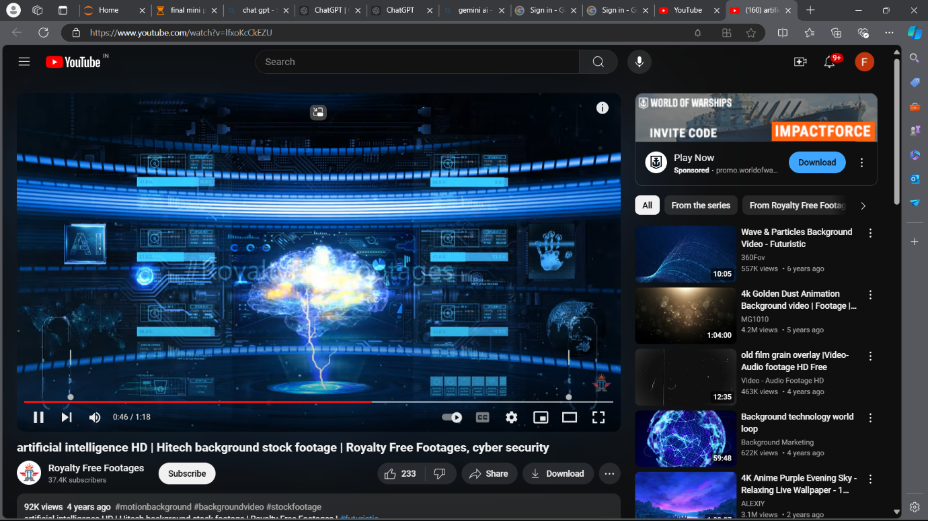

**CHAPTER-5**

**FLOWCHART**

**Flowchart: Voice Assistant Using Deep Learning and Python**

**User Input (Voice Command):**

The user speaks a command or asks a question.

**Speech Recognition:**

The system converts the spoken words into text using speech-to-text technology.

**Natural Language Processing (NLP):**

The system processes the text to understand the language, context, and meaning of the command.

**Intent Detection:**

The assistant identifies the user's intent from the processed text (e.g., setting a reminder, fetching information).

**Query Processing:**

The system retrieves information from its knowledge base or interacts with external services (e.g., web searches, controlling smart devices).

**Response Generation:**

Based on the user’s request, the system generates a response, either through text or an action.

**Text-to-Speech Conversion:**

If a verbal response is required, the system converts the generated response back into speech.

**User Receives Response:**

The user hears or sees the response.

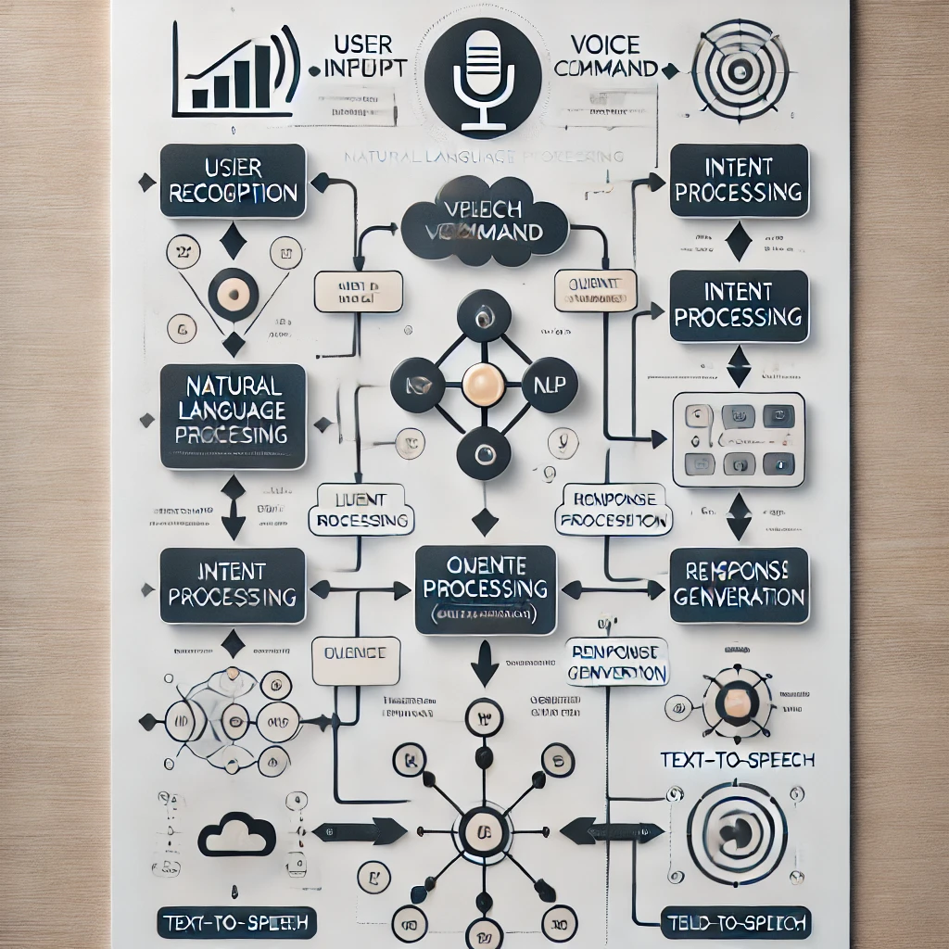

**CHAPTER-6**

**TOOLS AND LIBRARIES**

**Speech Recognition**

Google Speech-to-Text: Cloud-based service offering high accuracy and real-time processing.

Microsoft Azure Speech: Provides speech recognition and synthesis with integration into Azure services.

CMU Sphinx (PocketSphinx): Open-source, offline speech recognition; suitable for embedded applications.

DeepSpeech: Mozilla's open-source engine using deep learning for speech-to-text conversion.

**Natural Language Processing (NLP)**

spaCy: Fast and efficient library for advanced NLP tasks with pre-trained models.

NLTK (Natural Language Toolkit): Comprehensive library for various NLP functions, ideal for prototyping.

Hugging Face Transformers: Offers pre-trained models for intent recognition and entity extraction.

**Text-to-Speech (TTS)**

Google Text-to-Speech: Converts text to natural-sounding speech with API support for various languages.

Amazon Polly: Cloud service that generates lifelike speech with multiple voice options.

eSpeak: Lightweight open-source synthesizer suitable for embedded systems.

pyttsx3: Offline text-to-speech library in Python, compatible across platforms.

Development Frameworks

Rasa: Open-source framework for building conversational AI with intent recognition and dialogue management.

Microsoft Bot Framework: Comprehensive platform for developing chatbots and voice assistants.

**Voice Activity Detection (VAD)**

webrtcvad: Simple library for detecting voice activity in audio streams efficiently.

**Additional Tools**

Node.js and Express: Frameworks for building web applications and REST APIs for voice services.

Flask or Django: Python frameworks for developing web applications and APIs.

Docker: Tool for containerizing applications to ensure consistent environments.

Git: Version control system for managing code and collaboration.

**CHAPTER-7**

**Conclusion**

The voice assistant project exemplifies the significant potential of voice interaction technologies developed in Python. Throughout the implementation, we explored the integration of essential libraries, such as Speech Recognition and pyttsx3, showcasing their effectiveness in facilitating seamless communication between users and devices. This project not only highlights the feasibility of voicedriven interfaces but also emphasizes their utility in enhancing daily tasks, from managing schedules to fetching information in real time.

Key findings reveal that voice assistants can significantly improve user convenience by enabling handsfree operation, which is particularly beneficial in multitasking environments. However, challenges remain, including issues related to accuracy in diverse speech patterns and potential privacy concerns surrounding data collection.

Looking ahead, several future directions are worth pursuing. First, expanding language support and contextual understanding could make voice assistants more inclusive and capable of handling complex queries. Integration with smart home devices would enhance functionality, allowing users to control their environments effortlessly through voice commands.

Additionally, advancements in natural language processing (NLP) and machine learning could lead to more sophisticated voice assistants that better understand context and nuance in conversations. By training models on diverse datasets, these systems could learn to adapt to different accents and dialects, improving accuracy across a wider range of users. This would not only enhance user satisfaction but also broaden the accessibility of voice technologies for individuals with varying communication styles.

Moreover, addressing privacy and security concerns will be crucial as voice assistants become more prevalent in daily life. Implementing robust encryption methods and transparent data handling practices will help build user trust. As the technology evolves, it will be important to maintain a balance between convenience and security, ensuring that users feel safe while enjoying the benefits of handsfree interactions. By focusing on these areas, future developments in voice assistant technology can create even more enriching and secure experiences for users.

Voice assistance systems have emerged as a transformative technology, reshaping how users interact with digital devices and services. By offering a hands-free, intuitive interface, they provide a level of convenience and efficiency that enhances daily tasks, from retrieving information to managing smart home environments. With advancements in Natural Language Processing (NLP), speech recognition, and machine learning, these systems are increasingly capable of understanding complex commands, recognizing diverse accents, and adapting to individual user preferences, making them more accessible and user-friendly over time.

The integration of voice assistants with various platforms and devices further expands their functionality, enabling users to control smart homes, access services, and manage tasks seamlessly. This interconnectedness across ecosystems like smartphones, IoT devices, and cloud-based services has made voice assistants a central hub for personal and professional use. As technology evolves, the ability of voice assistants to integrate with more complex systems and provide real-time responses will become even more essential, driving innovation in automation, communication, and smart technology.

However, alongside these advancements, there are important ethical considerations, particularly regarding user privacy, data security, and potential biases in speech recognition. Developers and companies must focus on building secure, transparent, and equitable systems that protect users while enhancing their experiences. Overall, voice assistance technology will continue to play a significant role in shaping the future of digital interactions, offering greater accessibility, personalization, and convenience across various domains.

**CHAPTER-8**

**REFERENCES**

* **Speech Recognition Library**: [SpeechRecognition Library Documentation](https://pypi.org/project/SpeechRecognition/)
* **pyttsx3 Library**: [pyttsx3 Documentation](https://pyttsx3.readthedocs.io/en/latest/)
* **os Module**: [Python os Module Documentation](https://docs.python.org/3/library/os.html)
* **Source code:** https://github.com/koushikbu2006/mini-project/blob/main/final%20mini%20project.py